Acharya Institute of Technology

Department of Electronics and Communication Engineering



CREATIVE ASSIGNMENT

Subject: Introduction to Electronics and Communication Engineering
Subject Code: 1BESC204C

Report on

“Simulation of Analog and Digital Circuits using
Multisim Tool”

Submitted to

Mrs. Sumangala S J
Assistant Professor
ECE Department
AIT

Submitted by

Name of Student: _VINAYAK SALAPUR

USN: 1AZ25CS188 Dept: CSE

SEM: __ 2ND___ SECTION: B__

2025-26

- ANALOG CIRCUIT SIMULATION

Simulation of Wein Bridge Oscillator working of the circuit

Circuit Diagram:

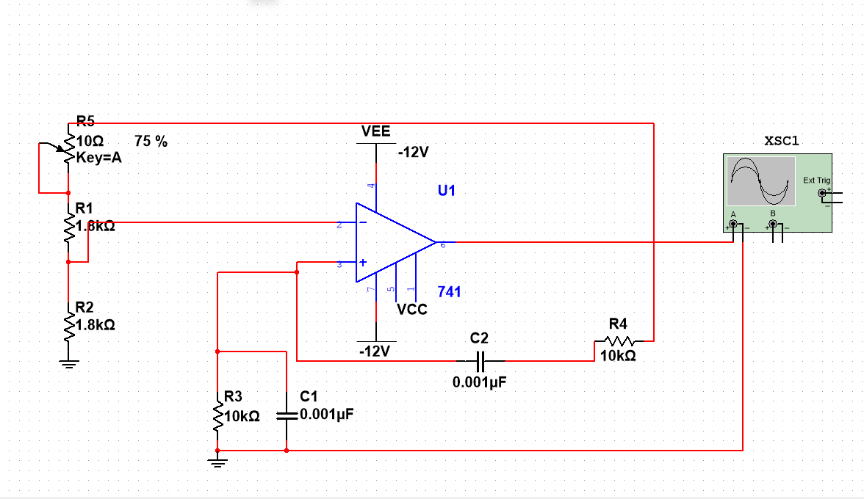

Working:
When current flows through the Vcc, the bridge circuit begins oscillating, utilizing the capacitor and resistor. A total phase shift of 360 degrees is achieved to ensure proper positive feedback, facilitated by the two transistors.

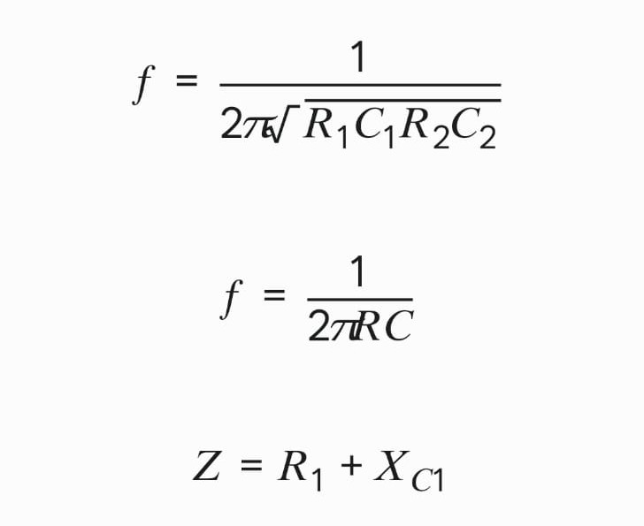

Output waveforms:

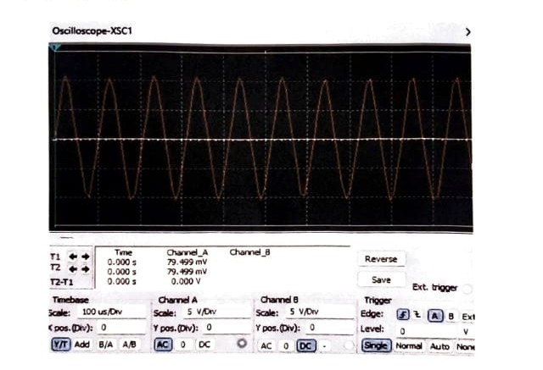

Inference:
The Wien Bridge Oscillator is an analog circuit that generates sinusoidal waveforms with high stability and low distortion. The overall gain of the oscillator is high.

- DIGITAL CIRCUIT SIMULATION

Verification of all logic gates Truth table by Simulation:

Circuit Diagram:
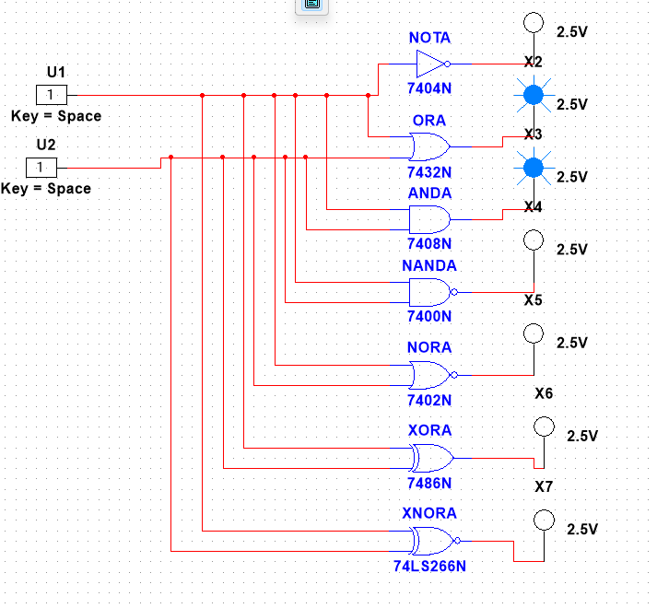

Working:

Logic gates work based on a combination of digital signals coming from its inputs. At any given moment, every terminal is in one of the two binary conditions: true or false.

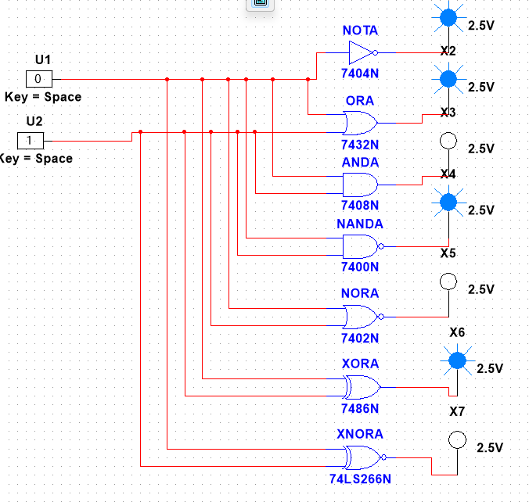
Simulation results:
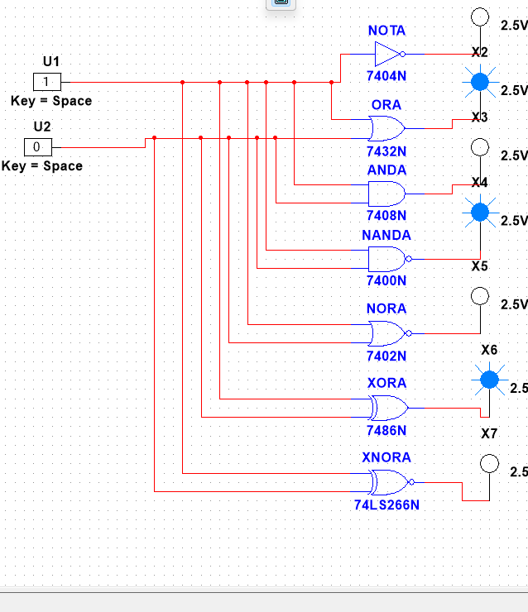
A=0,B=1
A=1,B=0

A=0,B=0
A=1,B=1
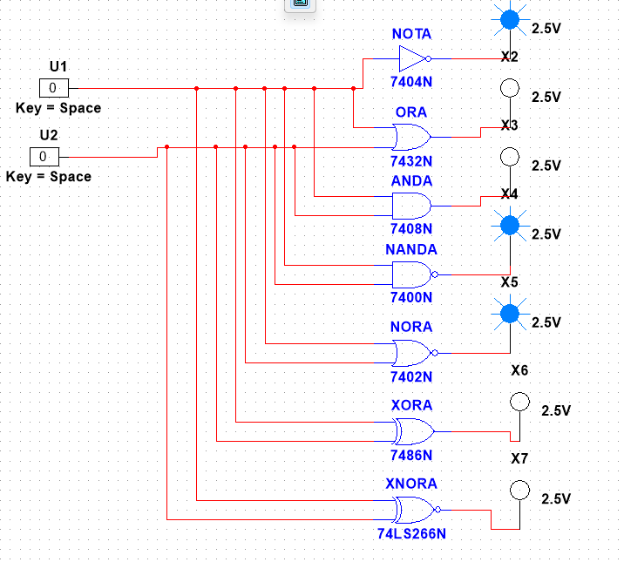

TRUTRH TABLE:

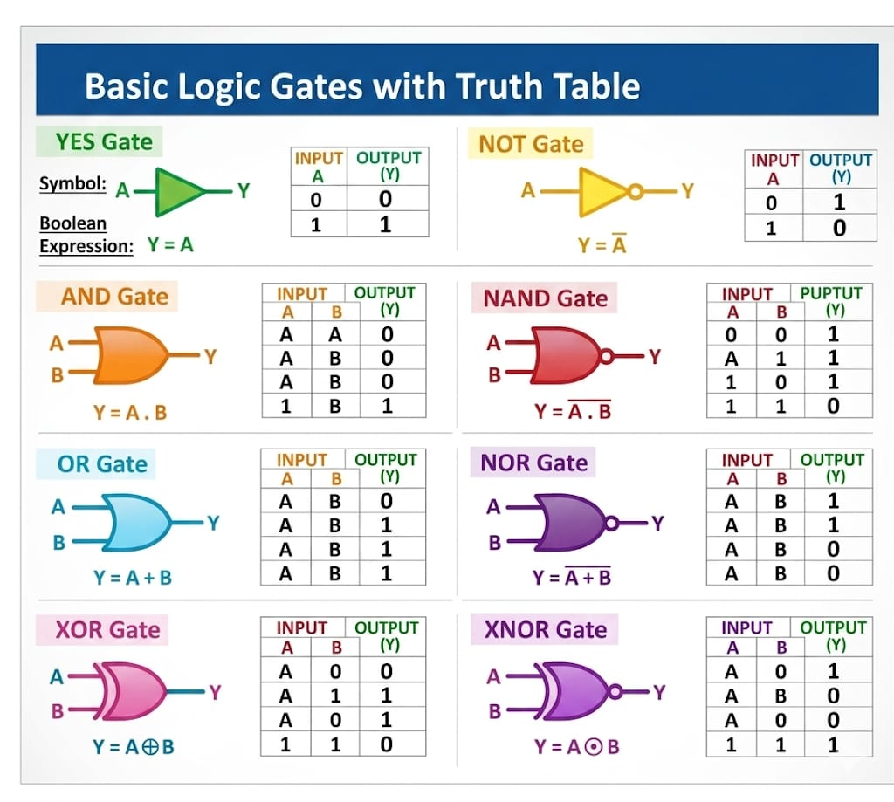

Inference:
This simulation demonstrates the logic behaviors of the gates and how to realize other gates with NAND and NOR gates.

